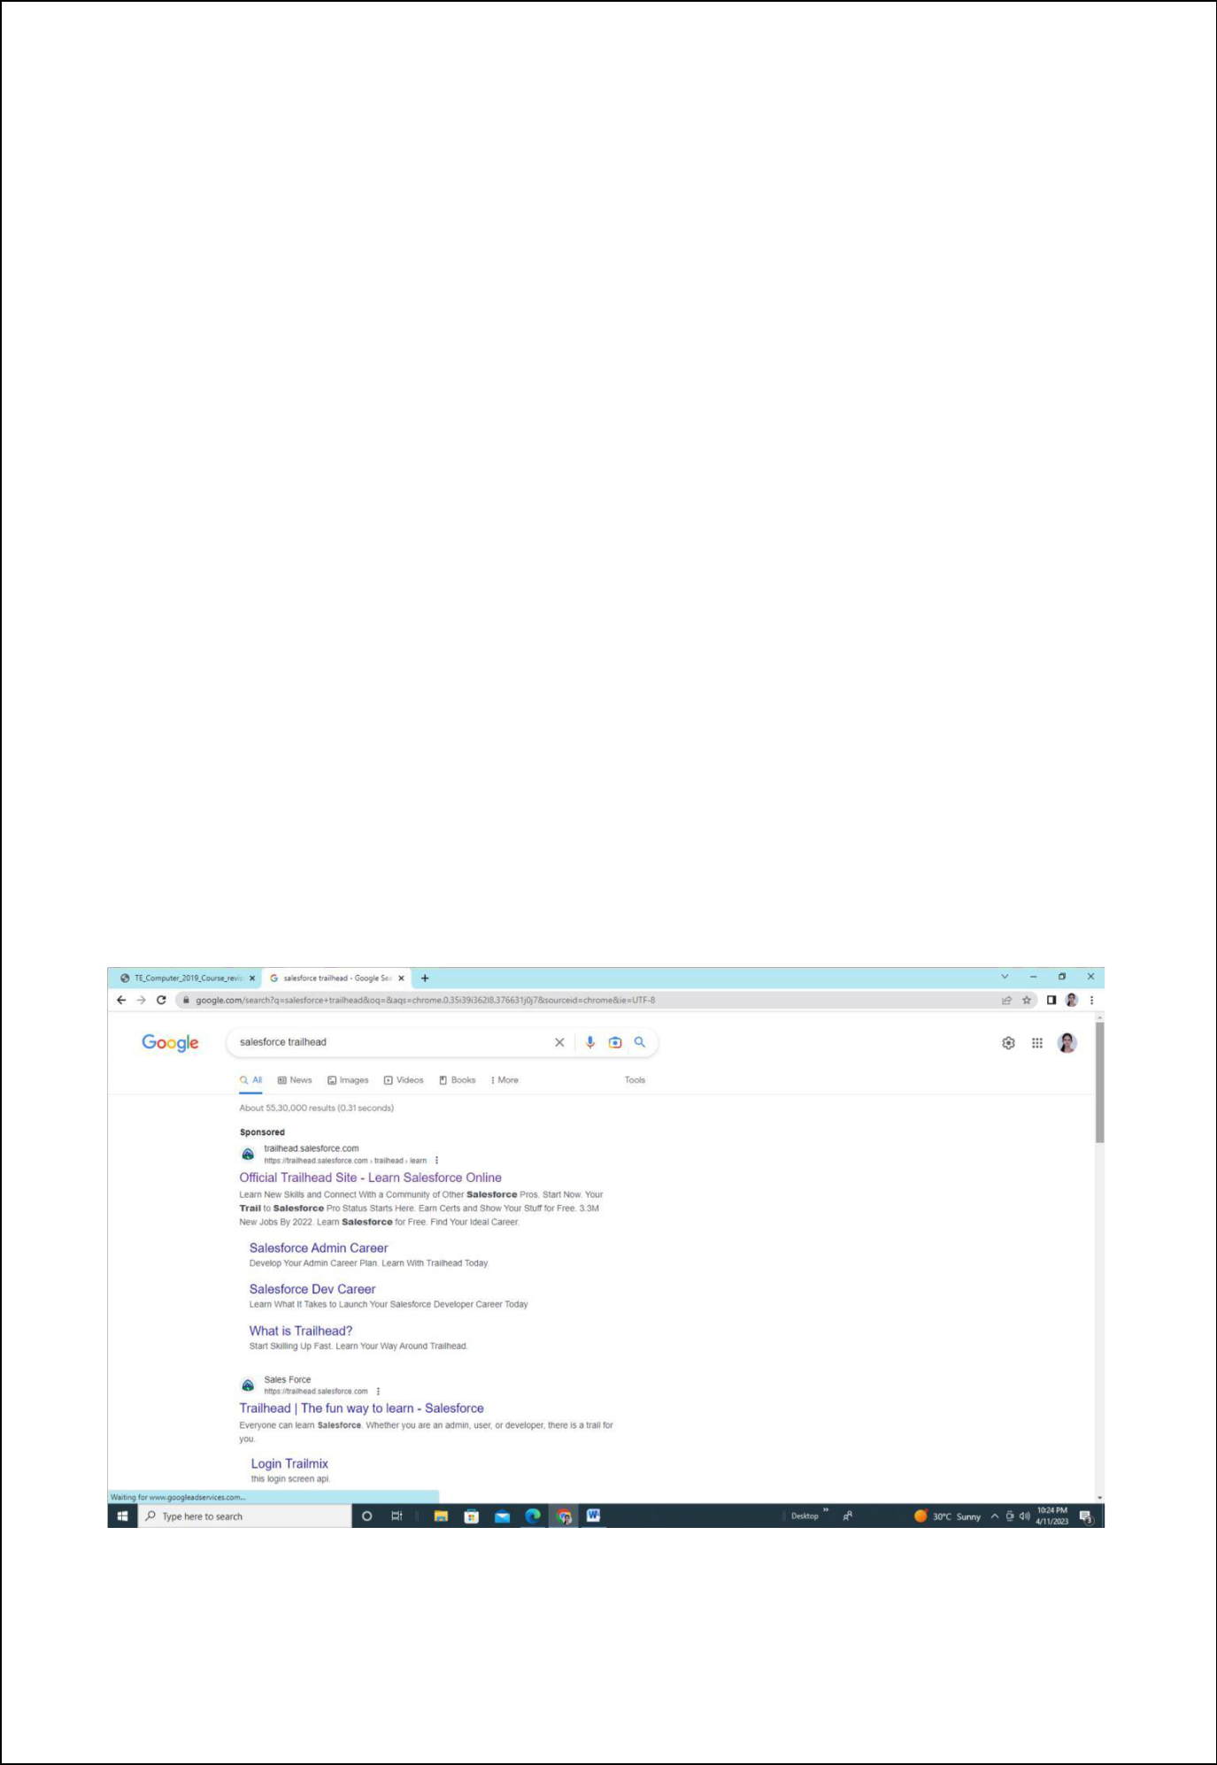
Assignment 04

Name: Sarthak Niranjan Kulkarni
Roll No: T211075

Div: A

Aim-: Assignment Design and develop custom Application (Mini Project) using Sales force Cloud.

Implementation steps:-

- From the Home tab in Setup, enter App in the Quick Find box, then select App Manager.

- Click New Lightning App.

- Walk through the Lightning App Wizard, creating an app with these parameters. App Name. ...

- Click Save and Finish to exit the wizard. 5. From the App Launcher 6. Check out the new app!

Step-1: Search Salesforce Trailhead in search bar
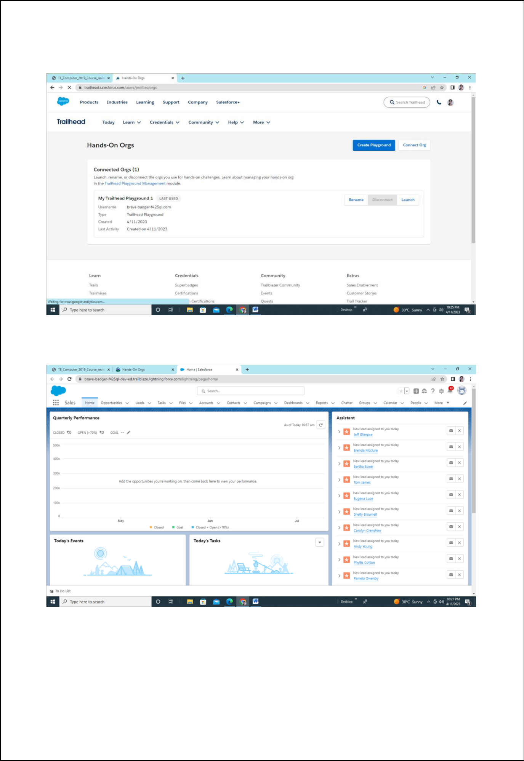
Step-2: Select hands on org

Step3: Click on setup
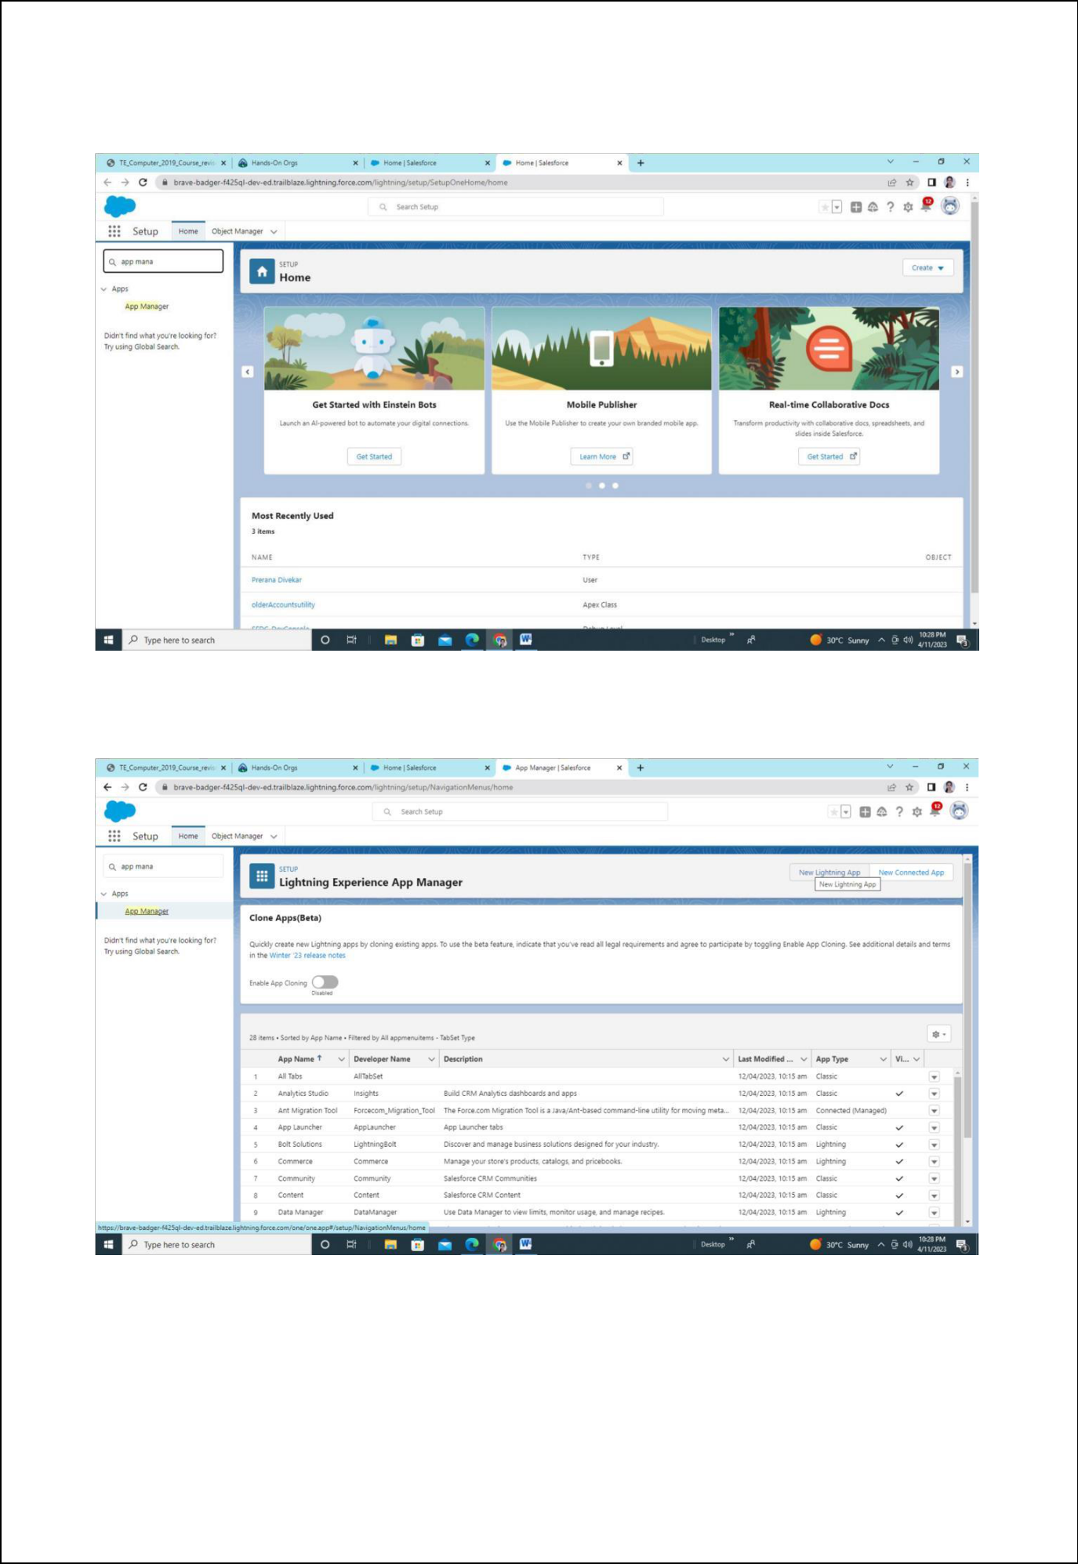
Step 4: Search app manager

Step 5: Select New Lightning App
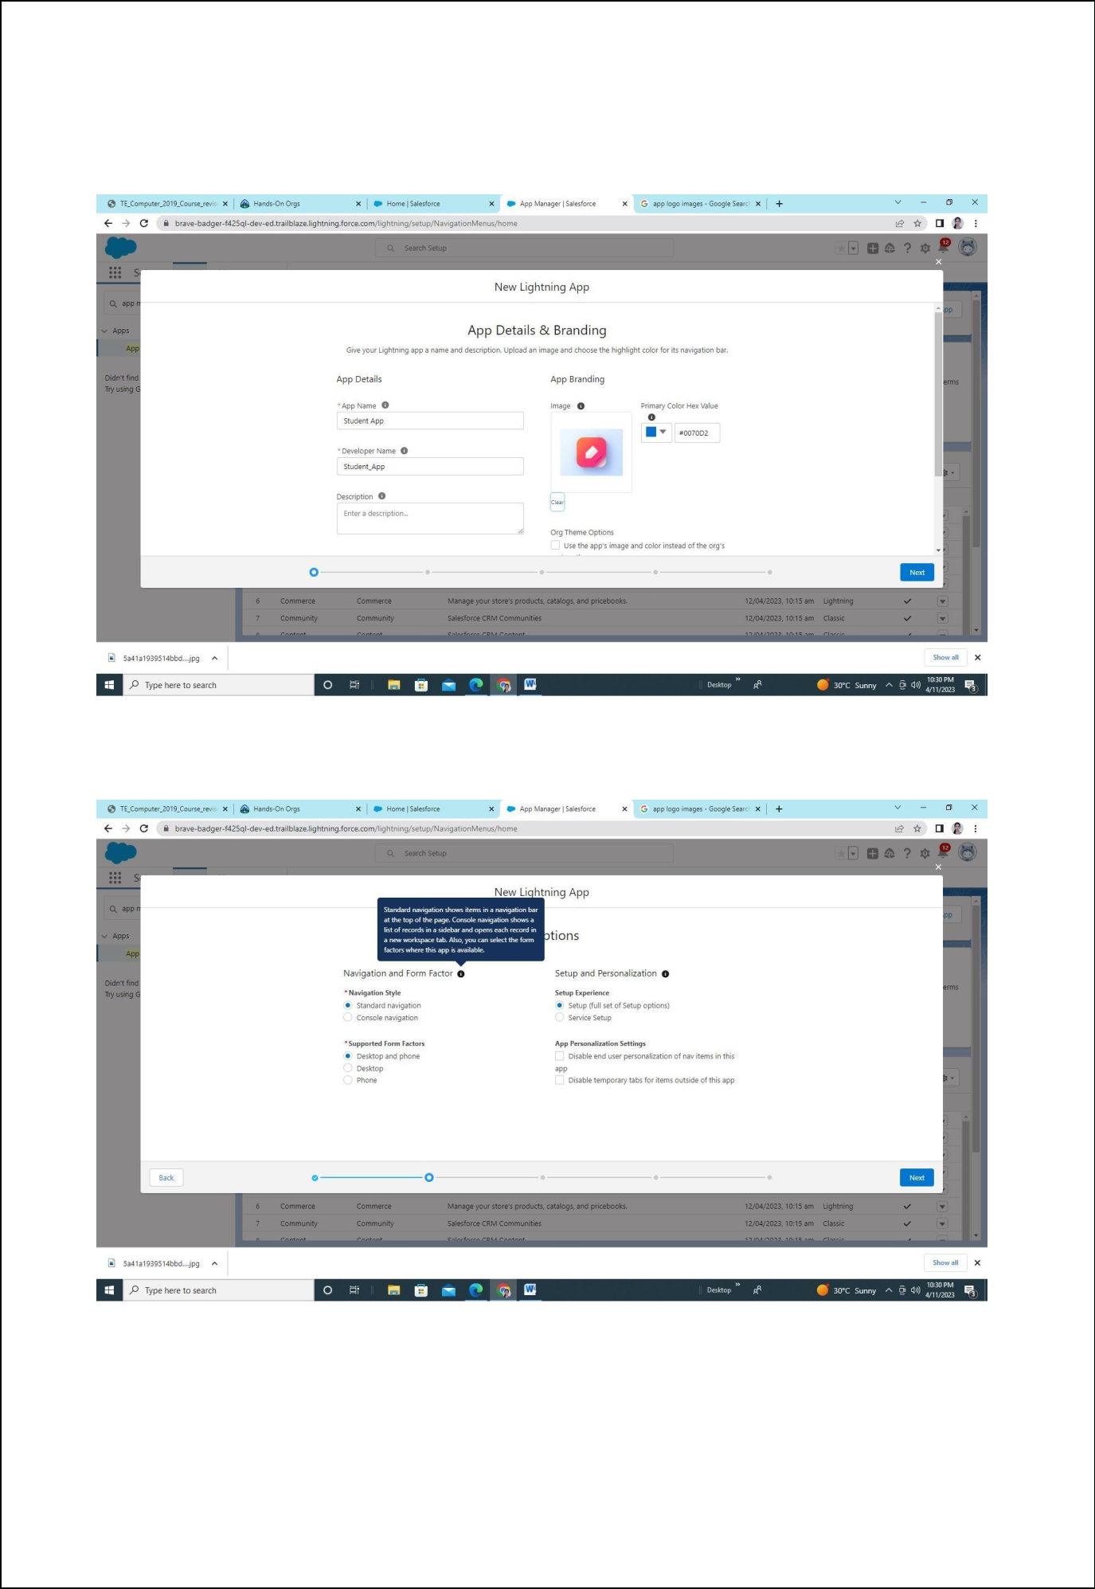
Step 6: Insert app name

Upload app logo image and click

Step 7: Click on next
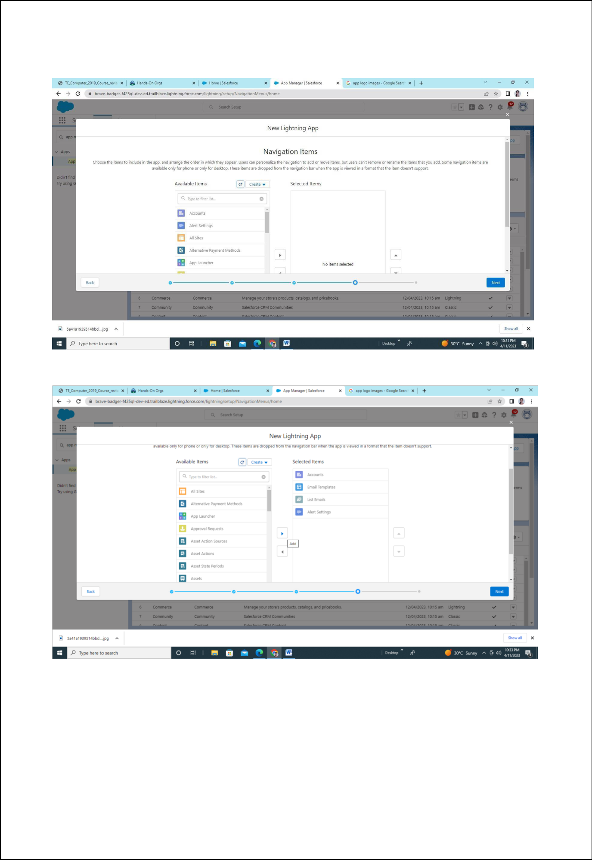
Step 8: Click on next
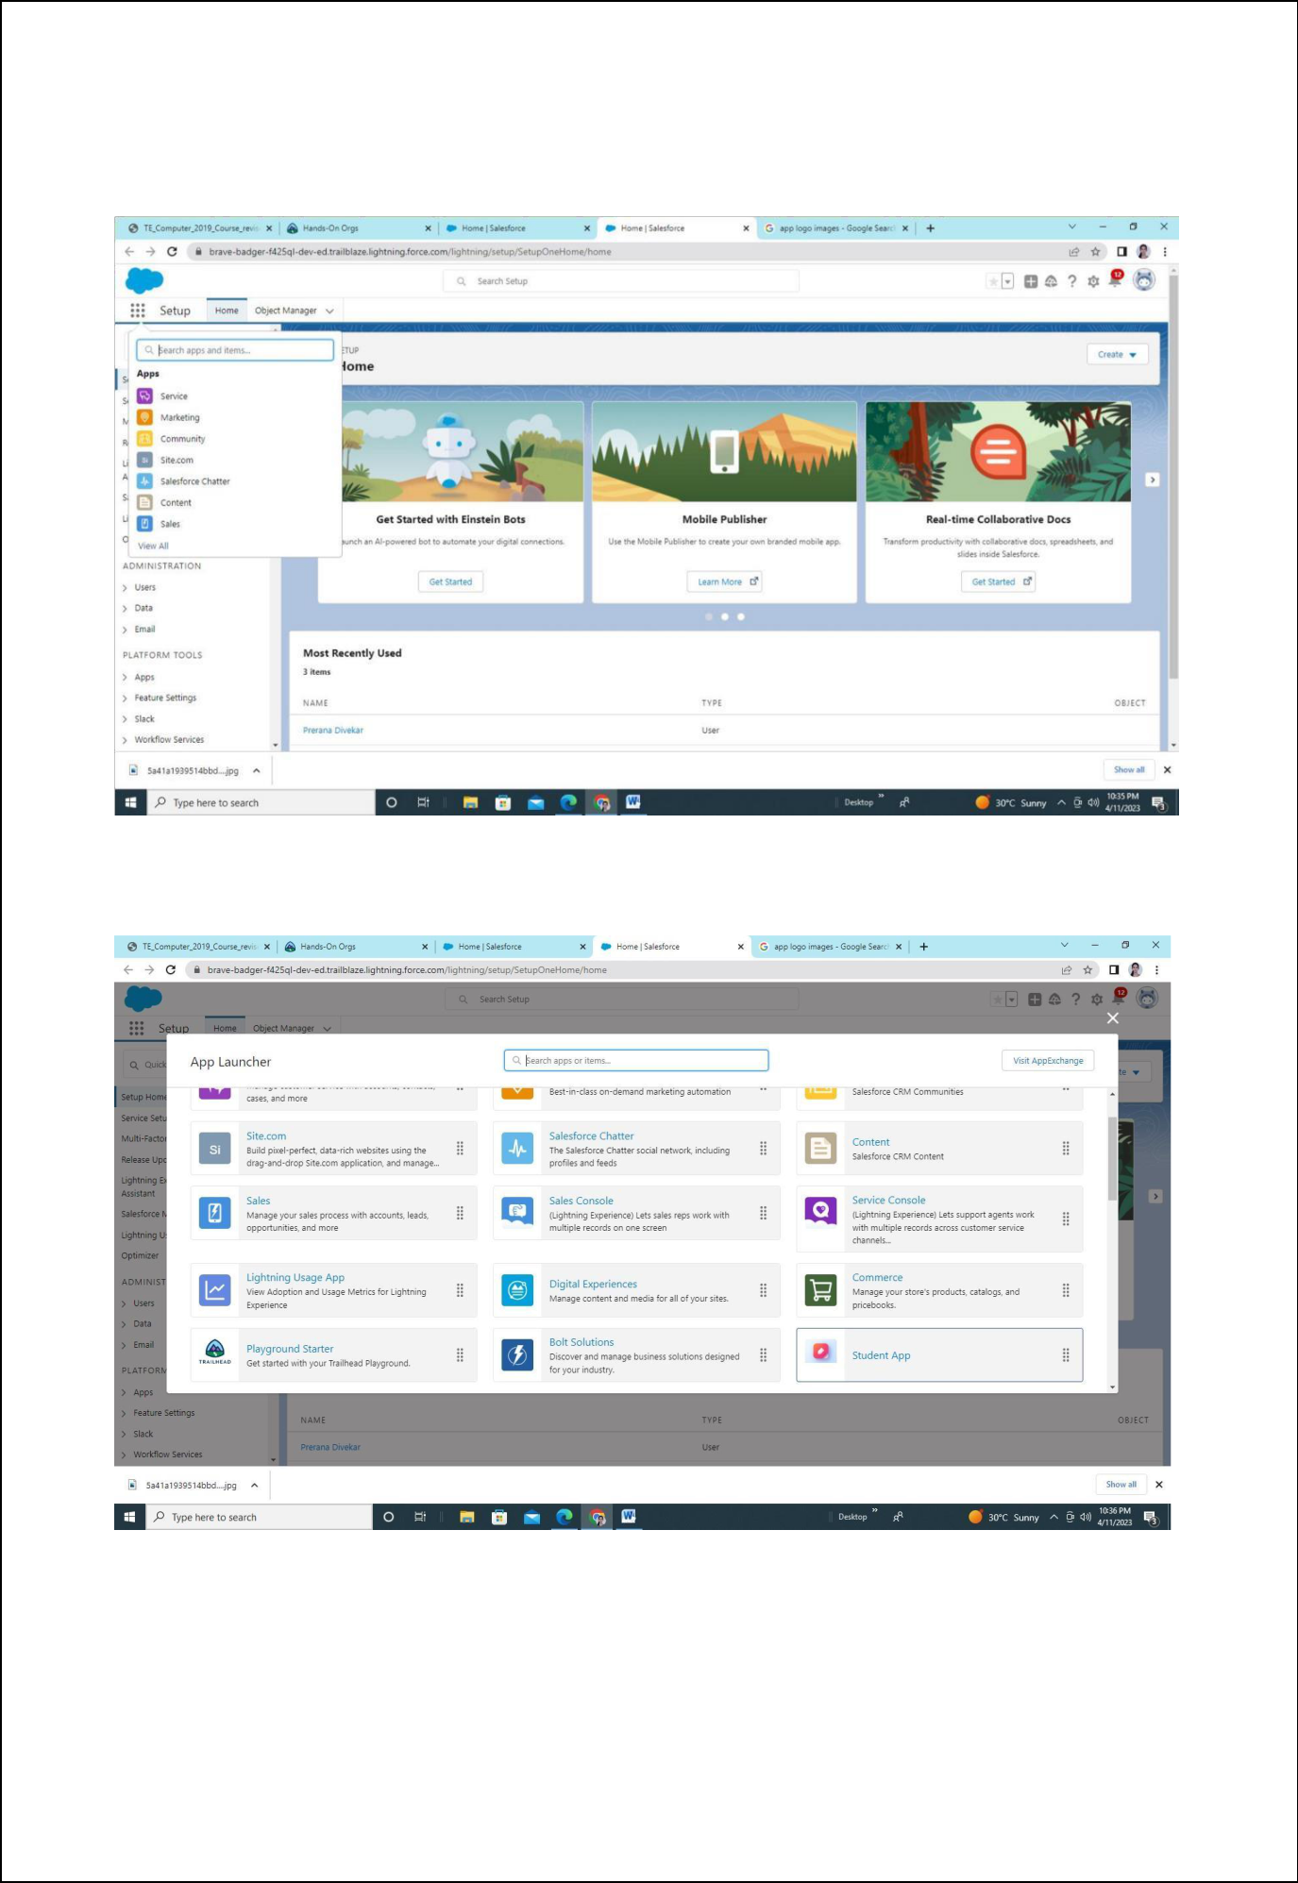
Step 9: Click on view all

Step 10: Select your app name
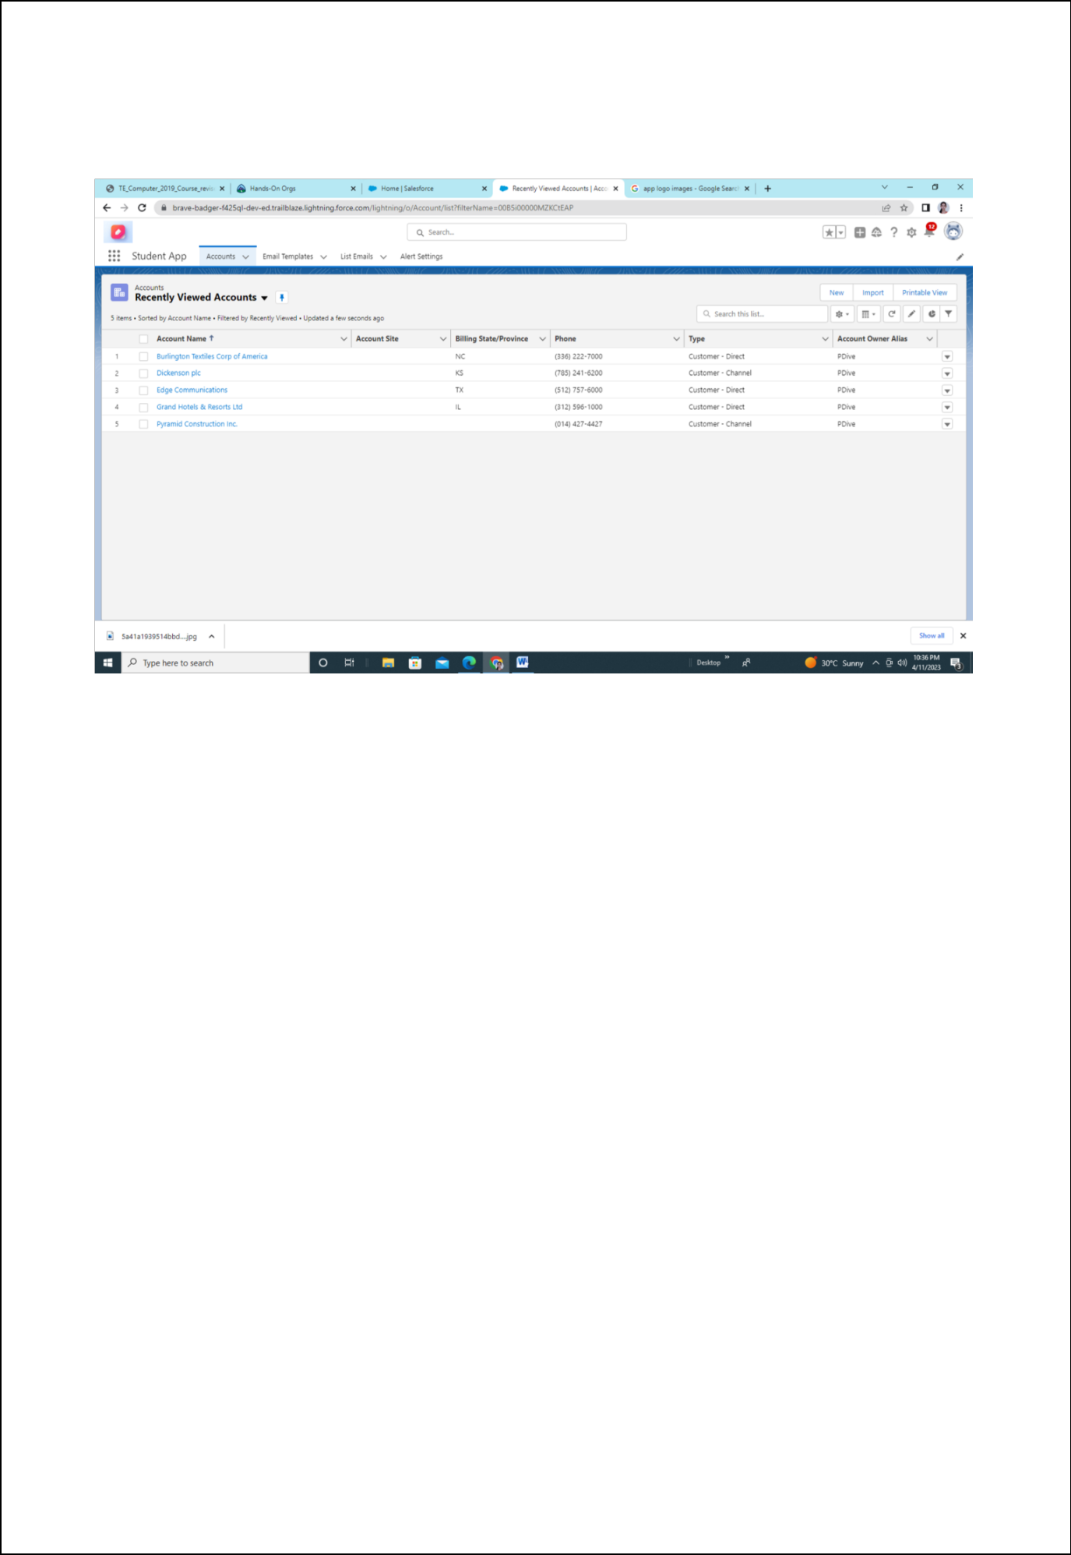
Step 11: This is your app

